Legislative Fellows Program

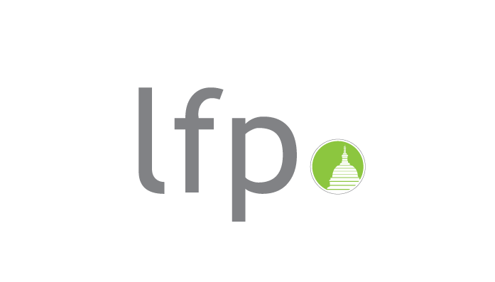

Application Form

Please submit the application via email to:
vladimir.spencer@worldlearning.org
marion.bernstein@worldlearning.org

Submission Deadline
November 5, 2009

Dear Applicants,

To strengthen the understanding of the U.S. legislative branch and civil society’s role in the political process, and foster relationships among Asian and American institutions, World Learning (WL) will implement, in 2010, the Legislative Fellows Program for South and Central Asia, a two-way exchange project for professionals and young leaders from Bhutan, India, Kazakhstan, Kyrgyzstan, Nepal, Pakistan and the U.S. The program is sponsored by the U.S. Department of State. For the implementation of the program, World Learning works in partnership with PRS Legislative Research (India), NGO Echo (Kazakhstan), Education Network Association (Kirgizstan), Foundation for Parliamentary Studies and Development (Nepal), and The Center for Peace and Development Initiatives (Pakistan). WL is an American educational and development organization with many decades of training, exchange, and youth leadership development experience. Through the program, 36 young emerging leaders from the six Asian countries and 5 young emerging leaders from the U.S. will gain knowledge and leadership skills to become more engaged in their communities, and get to know each other’s country, as well as learn about each group members’ ethnically, religiously, and nationally diverse background.

The Legislative Fellows Program for South and Central Asia will increase institutional capacity in local and national governments and political organizations. Through experiential activities, discussion, site visits, training modules, and professional fellowships, participants will have the opportunity to increase their understanding of the U.S. legislative process while engaging in civic life in the United States. Participants from the six countries and the United States will explore facets unique to each country’s history and identity, and engage in discussion and educational activities that promote learning on an academic and a personal level. Following are themes and topics related to legislation and governance that may be included in the program, as well as those proposed by participants – multiculturalism, ethnic/religious tolerance, social justice, emerging democracies, grassroots democracy, freedom of the press, environment, building civil society, transparency and government oversight, conflict resolution, economic development, worker rights, and the role of women. The program goals are as follows. Participants will:

- Gain an understanding of the U.S. legislative process
- Enhance their appreciation for the role of civic society and its engagement in the political process
- Increase their understanding of the minority and immigrant experience in the United States, especially as it relates to political integration and governance
- Improve their knowledge base and practical competencies to help strengthen organizational capacity
- Develop and implement projects or programs in their home country that promote good governance, civil society, and solid institutions
- Create linkages between American and Asian governments, institutions, and citizens
- Increase regional cooperation among governments and civil society

In April-May 2010, the first group of 18 grantees from the six countries will participate in a four-week U.S. experiential program (to be repeated in October-November 2010 for the other 18 grantees) that includes fellowships, interactive seminars, site visits, and synthesis discussions. In-country workshop tours and consultations by American grantees will take place in the summer of 2010 and early 2011. The U.S. programs will begin with an orientation in Washington, DC focusing on U.S. history, legislative process, and diversity. Following is a three-week fellowship in either Cleveland or Columbus, Ohio, which includes professional assignments, seminars, homestays, and volunteerism. The final segment brings the groups back to Washington, DC for high-level meetings with government and Congress, and a final evaluation.

Accommodation will include home-stays with American families and peers. A small stipend will be provided during the participants’ time in the United States to cover basic living expenses. The cost of international and domestic travel, program related ground transportation, cultural activities, and all the other programmatic and logistical arrangements will be covered.

Program participants will include college graduates, approximately 25 to 35 years old, with experience in political and legislative arenas. Participants will have demonstrated leadership abilities and a commitment to participation in the political process or policy-making through involvement in civic education activities, citizen advocacy groups, political campaigns, political parties, or election monitoring.

Diversity is particularly crucial for this program. Strong English language skills are required as the participants will need to converse about complex political and global issues with US peers and experts. To select the best candidates, we will review applications based on clearly defined criteria, including:

- Openness to dialogue and new ideas
- Good potential to play an increasingly important role in the society;
- Proven commitment to nonviolence; and
- Interest in participating in the program and sharing the experience with colleagues and the public.

Preference would be given to applicants with relevant professional achievements who have not previously visited the United States. The candidates should be able and willing to host American counterparts, for up to a week, and design, arrange, and coordinate, under WL and its partners’ supervision, a local professional and cultural program for the American participants.

Please find the application form below. The application must be completed in English. The deadline for submitting the application is November 5, 2009. Applications will be reviewed and considered as they arrive. Early applications are encouraged. We appreciate your interest in this project and look forward to working with you.

Sincerely,

Vlad Spencer
Assistant Director
World Learning Visitor Exchange Program

U.S. EXCHANGE PROGRAM APPLICATION

Applications should be in English and e-mailed with the subject line “Legislative Fellows” to:

Mr. Vlad Spencer E-mail: vladimir.spencer@worldlearning.org
Ms. Marion Bernstein E-mail: marion.bernstein@worldlearning.org

For more information on program specifics, contact the e-mail addresses above. Please include with your application a scanned copy of your passport bio page (the page with the picture and personal information). The page is needed to process the visa application expeditiously in case you are selected.

APPLICATION DEADLINE: Saturday, November 5, 2009

THIS APPLICATION FORM IS FREE OF CHARGE AND MAY BE DUPLICATED

Information About You

Name
LAST First Middle

Permanent address
Permanent telephone
E-mail where you can be most easily contacted:
Date of birth | Day/month/Year | ٱ | male | ٱ | female | Marital Status: | __ Married  __ Single
Do you have a valid passport? | Yes / No

Where did you first hear about this program? (Please be as specific as possible.)

Have you previously traveled to the United States? | Yes / No

Professional Information (Take as much room as you need to write your answers. If necessary, attach another sheet of paper.)

Name of employer
Your Job Title
Full work address
Work Telephone
Work Fax
E-mail address
Supervisor’s name

Describe your job responsibilities

Concurrent Professional Positions

List your concurrent job titles (if any), employer, years at position

Previous Professional Positions

List your previous job titles, employer, years at position (up to 5 previous positions)

Education (including current work-in-progress degrees)

Please list any degrees or diplomas earned, name of school, year received

Memberships

Please list any memberships or affiliations that you have

Languages

How would you describe your English skills?
Comprehension: Excellent _____ Good _____ Adequate _____ Poor _____
Reading: Excellent _____ Good _____ Adequate _____ Poor _____
Speaking: Excellent _____ Good _____ Adequate _____ Poor _____

Personal Information (Take as much room as you need to write your answers. If necessary, attach another sheet of paper.)

Please tell us about yourself

PLEASE ANSWER THE FOLLOWING PROGRAM-RELATED QUESTIONS

- What do you expect to learn and accomplish during the exchange program? How would your participation in the program enhance your professional career and personal development?

- You’ll be expected to host a visiting American peer and arrange a professional program in your community. Please explain what kind of local activities should be included in such a program in order for the American visitor to better understand your country’s political system and its culture.

- In order to contribute to sustainable professional growth and have a multiplying effect in your country and the U.S., the exchange program should identify projects and initiatives that young emerging leaders from both our countries could develop during and after the program, dealing with various aspects of politics and legislative affairs. What kind of follow-on activities and projects would you like to see implemented?

PROJECT IMPLEMENTATION QUESTIONNAIRE

Are you willing to be in double occupancy hotel rooms and home-stays during your U.S. trip? | Yes / No
Could you arrange, under World Learning’s supervision, a professional/cultural program for an American counterpart, during his/her stay in your country? | Yes / No
Are you wiling to participate in all stages of the program, including working on follow-on projects with your American counterparts? | Yes / No
Are you available to participate, either in person or via skype or yahoo messenger, in a selection interview during the months of November and December 2009? | Yes / No
Do you want to travel to the U.S. during the spring or the fall segment of the program? Indicate if you don’t have a preference. | Spring  Fall  No preference
Do you have a valid passport from your country? | Yes / No

I agree that all of the information in this application is true and I agree that if chosen, I will participate in ALL program activities in the United States and in my country, including the pre-departure orientation and follow-on activities.

Applicant Signature Date

Thank you for taking the time to complete this application. Good luck!

This program is funded by the U.S. Department of State, Bureau of Educational and Cultural Affairs,
Office of Citizen Exchanges.

